Steps to install automation project.

1. You should have access to GitHub.

2. Install Microsoft VS Code(Latest).

3. Install node.js for windows if you are using windows machine (Latest).

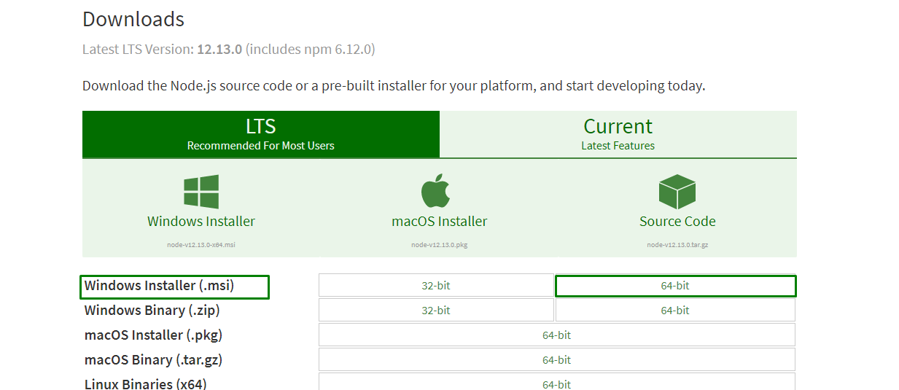

4. Install java. (above 1.8 version)

5. Configure the environment variable add path of node , java , Microsoft vs code, npm below configuration should be exactly same as demonstrate in the images.

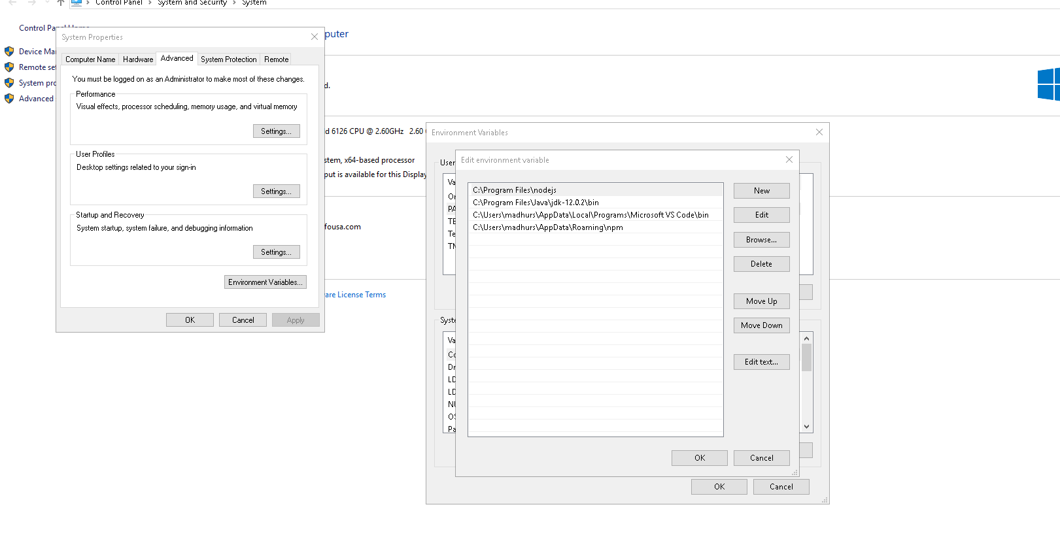

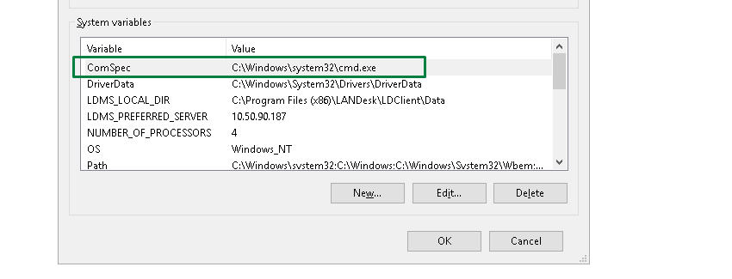

6. Open command prompt and run the below following command to start the server and don’t close this window , if you want to use command prompt open a new one but don’t close the server.

* node –v (it should give you node version that you are using)
* npm –v (it will give you npm version and it should be latest).
* npm install –g protractor (this will install protractor globally).
* webdriver-manager update (this will update the webdriver).
* webdriver-manager start (this will start the server).

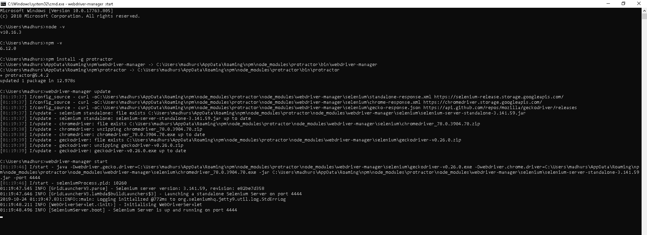

7. Take the latest code from VSTS in your local machine and you are good to go.

Path: IDMS_NG/QA/**Code**

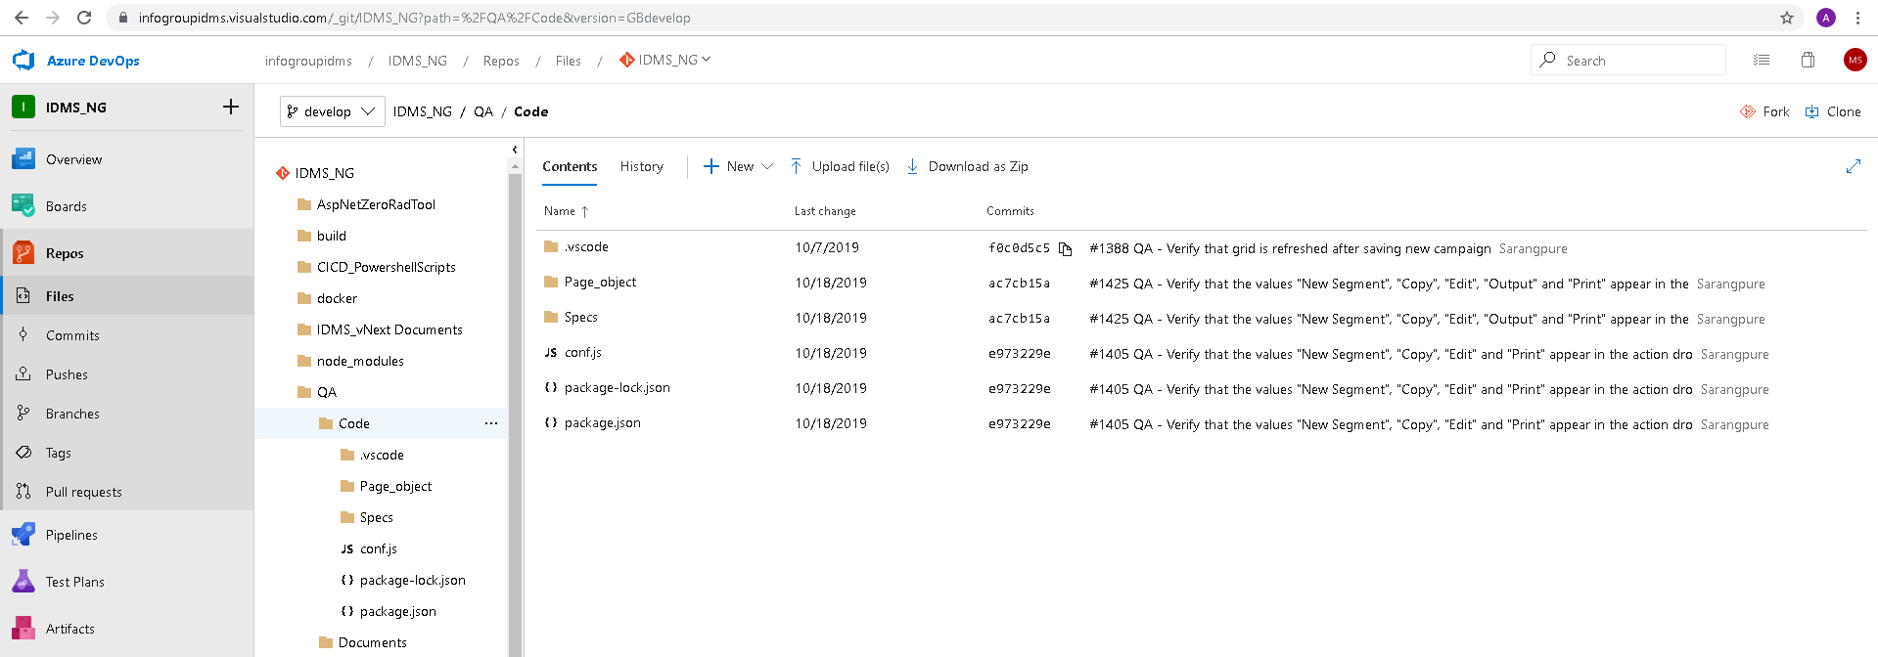

8. In Microsoft VS code open new terminal and run command npm install.

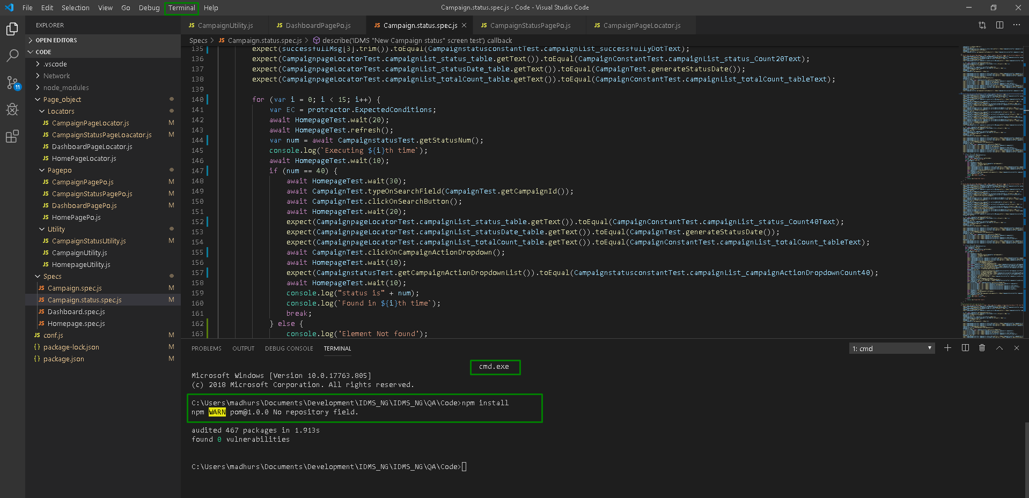

9. Run the suite by using command npm run test (Suite name) for eg: npm run test Campaignstatus.

